**CHALLENGING EXPERIMENT 4**

**Name: M.S.SANJAY Reg No.: 15BCE0517 Slot: L31+L32**

The following table gives the weight (*x*) (in 1000 lbs.) and highway fuel efficiency (*y*) (in miles/gallon) for a sample of 13 cars.

|  |  |  |
| --- | --- | --- |
| Vehicle | *X* | *Y* |
| Chevrolet Camaro | 3.545 | 30 |
| Dodge Neon | 2.6 | 32 |
| Honda Accord | 3.245 | 30 |
| Lincoln Continental | 3.93 | 24 |
| Oldsmobile Aurora | 3.995 | 26 |
| Pontiac Grand Am | 3.115 | 30 |
| Mitsubishi Eclipse | 3.235 | 33 |
| BMW 3-Series | 3.225 | 27 |
| Honda Civic | 2.44 | 37 |
| Toyota Camry | 3.24 | 32 |
| Hyundai Accent | 2.29 | 37 |
| Mazda Protégé | 2.5 | 34 |
| Cadillac DeVille | 4.02 | 26 |

Find the Correlation between X and Y

> x=c(3.545,2.6,3.245,3.93,3.995,3.115,3.235,3.225,2.44,3.24,2.29,2.5,4.02)

> y=c(30,32,30,24,26,30,33,27,37,32,37,34,26)

> var(x)

[1] 0.3517522

> var(y)

[1] 16.92308

> var(x,y)

[1] -2.190385

> r=var(x,y)/sqrt(var(x)*var(y))

> r

[1] -0.8977642

> cor(x,y)

[1] -0.8977642

> cor.test(x,y)

Pearson's product-moment correlation

data: x and y

t = -6.7598, df = 11, p-value = 3.116e-05

alternative hypothesis: true correlation is not equal to 0

95 percent confidence interval:

-0.9692870 -0.6862219

sample estimates:

cor

-0.8977642

> cor.test(x,y,method="spearman")

Spearman's rank correlation rho

data: x and y

S = 672.99, p-value = 0.0002426

alternative hypothesis: true rho is not equal to 0

sample estimates:

rho

-0.8488611

Warning message:

In cor.test.default(x, y, method = "spearman") :

Cannot compute exact p-value with ties

> cor.test(x,y,method="kendall")

Kendall's rank correlation tau

data: x and y

z = -3.3361, p-value = 0.0008495

alternative hypothesis: true tau is not equal to 0

sample estimates:

tau

-0.7205767

Warning message:

In cor.test.default(x, y, method = "kendall") :

Cannot compute exact p-value with ties

**There is a negative correlation between x and y.**

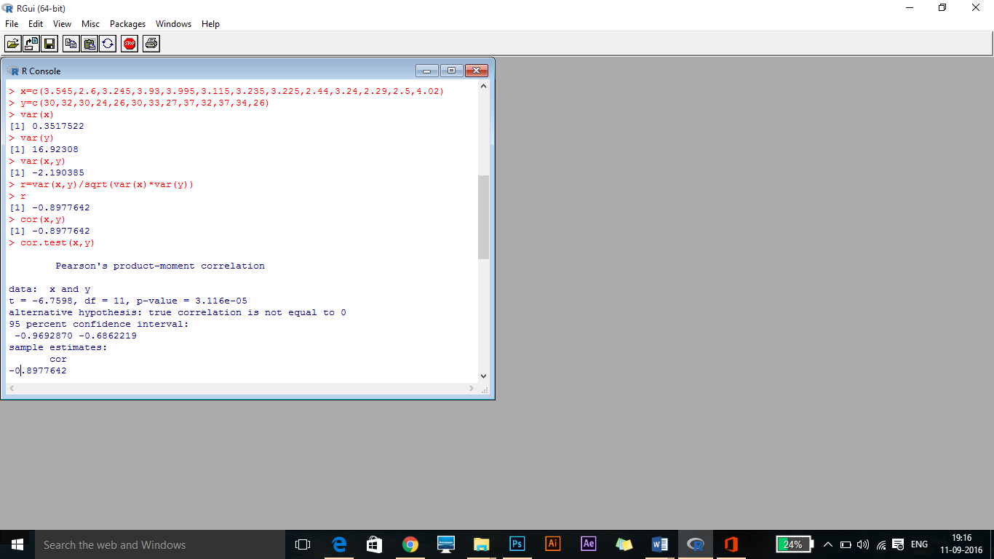

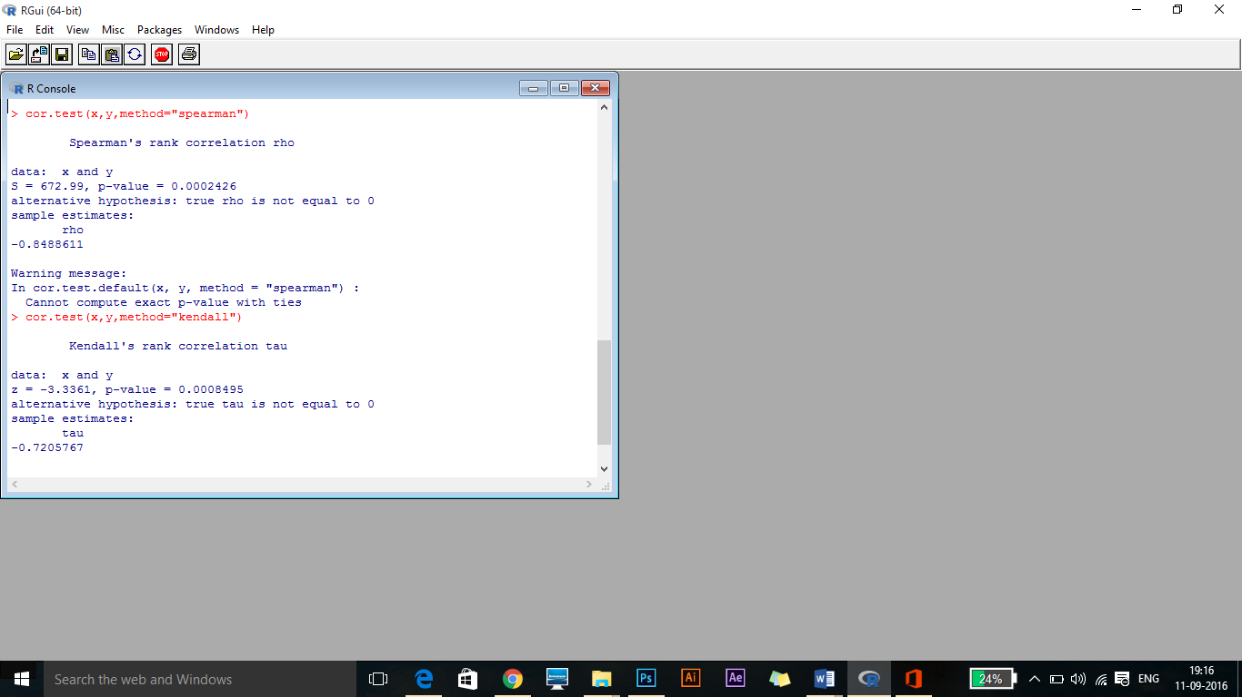

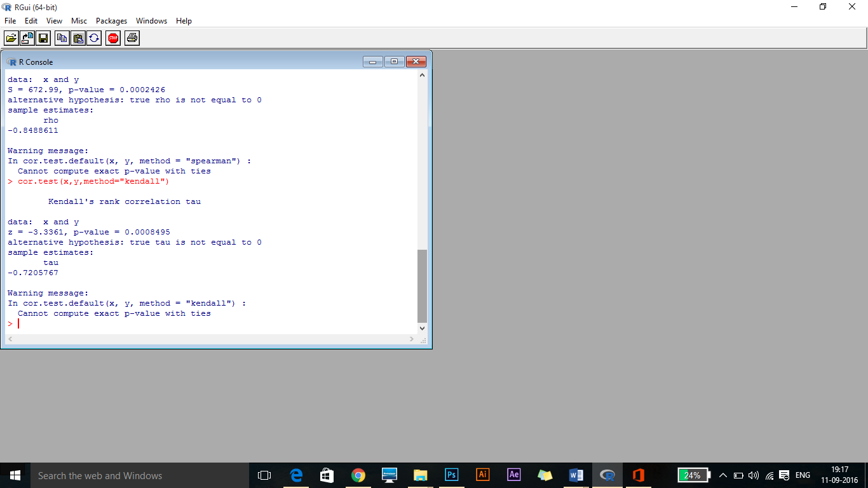

2. Find the Correlation between below data

|  |  |  |
| --- | --- | --- |
| ENJOY | BUY | READ |
| 4 | 16 | 6 |
| 15 | 19 | 13 |
| 1 | 0 | 1 |
| 11 | 19 | 13 |
| 13 | 25 | 12 |
| 19 | 24 | 11 |
| 6 | 22 | 7 |
| 10 | 21 | 8 |
| 15 | 13 | 12 |
| 3 | 7 | 4 |
| 11 | 28 | 15 |
| 20 | 31 | 14 |
| 7 | 4 | 7 |
| 11 | 26 | 14 |
| 10 | 11 | 9 |
| 6 | 12 | 5 |
| 7 | 14 | 7 |
| 18 | 16 | 12 |
| 8 | 20 | 10 |
| 2 | 13 | 6 |
| 7 | 12 | 9 |
| 12 | 23 | 13 |
| 13 | 22 | 9 |
| 15 | 19 | 13 |
| 4 | 12 | 9 |
| 3 | 10 | 5 |
| 9 | 7 | 7 |
| 7 | 22 | 8 |
| 10 | 7 | 8 |
| 2 | 0 | 2 |
| 15 | 16 | 7 |
| 1 | 17 | 6 |
| 3 | 11 | 9 |
| 6 | 5 | 9 |
| 13 | 29 | 15 |
| 15 | 29 | 11 |
| 16 | 20 | 9 |
| 14 | 16 | 7 |
| 1 | 3 | 2 |
| 8 | 8 | 10 |

**studydata=read.csv(“C:\\Users\\sachin\\Desktop\\book1.csv”)**

**studydata2<-studydata[,c(“ENJOY”,”BUY”,”READ”)]**

**cor(studydata2)**